The Woodlands Federation

Talbot First School  Church Lane  Kingstone  Uttoxeter  ST14 8QJ  office.talbot@woodlandsfederation.staffs.sch.uk | St Peter’s CE (VC) First School  The Square  Marchington  Uttoxeter  ST14 8LH  office.stpeters@woodlandsfederation.staffs.sch.uk
Dear Parents, Carers and Pupils,
Well…this has been an interesting half term to say the least! Well done to every one of you, you have coped and worked brilliantly and I know it hasn’t been easy. I will be continuing as Interim Head for the next half term and I am hoping that I will finally get to meet all of you. Schools do not feel right without being full of children but I know the staff have worked incredibly hard to make sure that children in and out of school have felt connected and still a part of these two wonderful schools. Thank you again for the support and appreciation you have shown for the hard work of the staff in the Woodlands Federation they have truly appreciated it.
Unfortunately, I do not know when we will all be able to meet up as there has been no news at all about a possible return apart from the target date of March 8th, which is still not confirmed. I will update you when I receive any news about a possible return. So we will continue with our online learning after the holidays. You will all be incredible IT technicians by the time we get back, I have been seriously impressed with how you have all developed your IT skills.
For Keyworkers whose children are attending school, we still need to be available to assist Track and Trace for the first 48 hrs of the holiday basically until 4.00pm on the first Sunday evening. So if your child develops symptoms of Covid 19 please contact the school using the email:
interimhead@woodlandsfederation.staffs.sch.uk
I will check the email twice a day for the first weekend at 9.00 am and 4.00 pm so I am able to start the track and trace process.
Please have a great rest over the half term holiday and I hope you manage to get out and enjoy the lovely countryside, Covid restrictions allowing!
Thank you all and I look forward to working with you, and hopefully getting to meet you all, after the holiday.
Take care, stay safe and keep well.
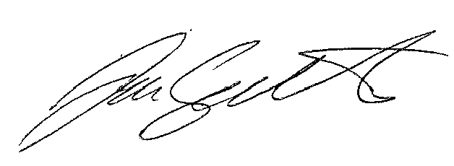
Mr Gathercole

