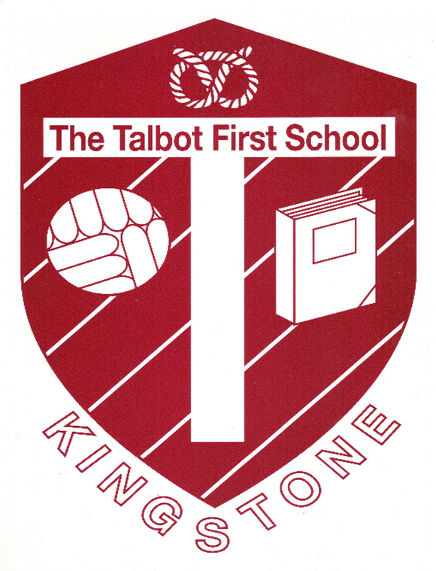
The Woodlands Federation

Talbot First School  Church Lane  Kingstone  Uttoxeter  ST14 8QJ  office.talbot@woodlandsfederation.staffs.sch.uk | St Peter’s CE (VC) First School  The Square  Marchington  Uttoxeter  ST14 8LH  office.stpeters@woodlandsfederation.staffs.sch.uk
4.1.21

Dear Parents and Carers,
I am sure you are all as shocked, stunned and frustrated as we are by the last minute decision for a full lockdown as announced at 8.00pm on the BBC news.
After my email confirming that both St Peter’s and Talbot schools would be open tomorrow, I now need to inform you that, sadly, we now need to close.
Remote learning will be sent tomorrow and later this week we will send detailed information on how we will increase the interactivity with teachers to assist pupils with that sense of connection with school.
We are still waiting for further guidance from the DfE and I will keep you up to date on any further developments.
I can only apologise for the late notice and frustration this will undoubtedly cause but this was out of our control.

My very best wishes.

Jason Gathercole.

