16th November 2020

Dear parents/carers,

This afternoon I received an email from Jonathon Price (Cabinet Member for Education) and Richard Harling (Director for Health and Care) who have shared some new information regarding when to go for a Covid-19 test. I have lifted the following text directly from the letter, please note the section approximately half-way down the extract beginning ‘However’;

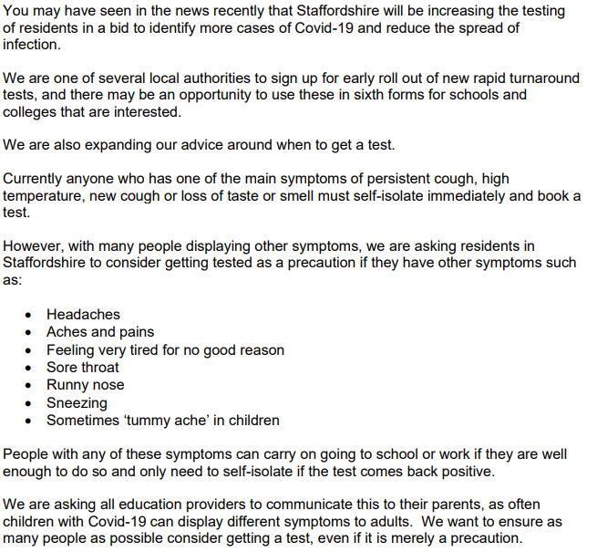

This is an interesting development and one which I strongly urge you to consider if you or anyone you know are displaying any of these symptoms.

Kind regards

Emma Manby

Interim Headteacher

